EXPERIMENT 14:
ANALYSIS OF EDFA-BASED DENSE WDM LINK PERFORMANCE USING OPTISYSTEM
OBJECTIVES :
1. To design and simulate a Dense Wavelength Division Multiplexing (DWDM) optical communication system using OptiSystem.
2. To investigate the impact of varying optical fiber length on overall system performance.
3. To examine the effectiveness of an Erbium-Doped Fiber Amplifier (EDFA) in compensating for fiber a enuation losses.
4. To evaluate and compare received power, bit error rate (BER), and Q-factor across different fiber lengths.
SOFTWARE REQUIRED: Opti System.
CIRCUIT DIAGRAM:

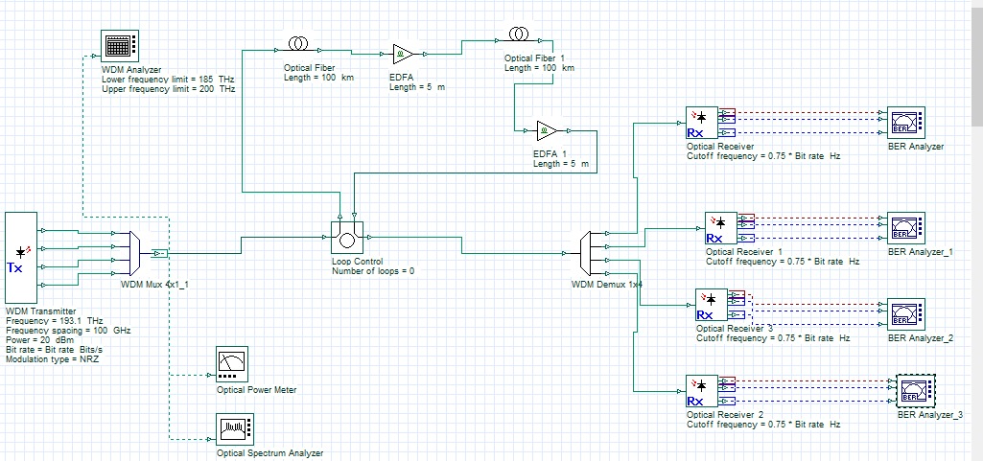

OUTPUTS:

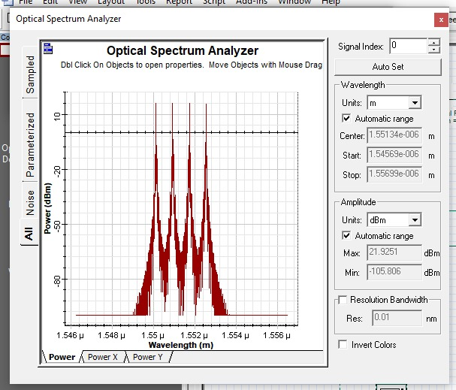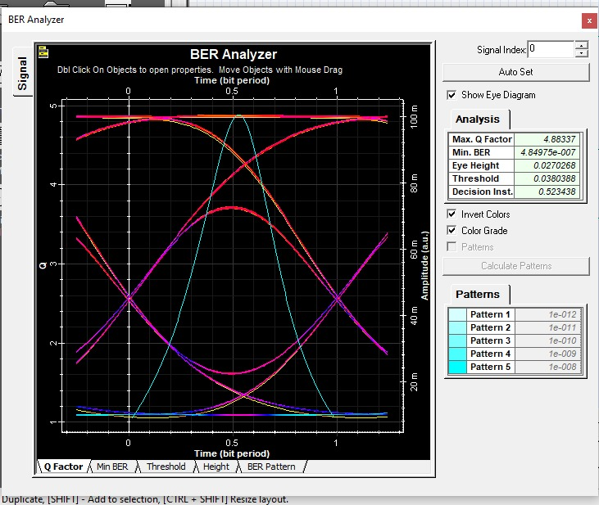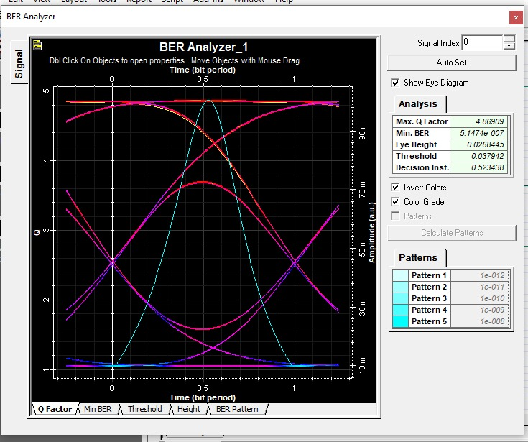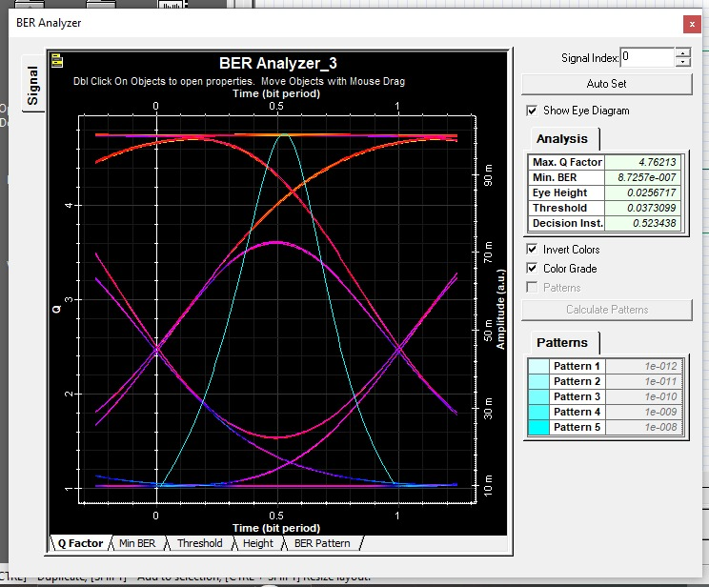
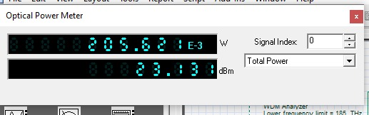

REFLECTION:

learned how multiple optical channels are transmitted through a single fiber using DWDM.
- I understood the function of an EDFA in compensating for fiber attenuation.
- I learned to analyze BER and Q-factor using BER analyzers.
- I understood how fiber length affects optical communication performance

RUBRICS:

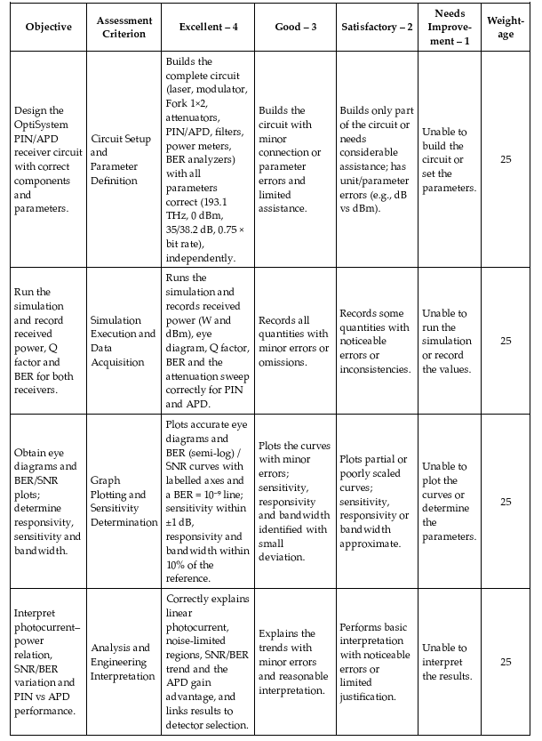
CONCLUSION :
The DWDM optical communication system was designed and simulated successfully using OptiSystem. The performance of the link was analyzed for different fiber lengths, and the role of the EDFA in compensating for fiber attenuation was studied. The BER and Q-factor results were recorded to evaluate signal quality. The experiment demonstrated the importance of optical amplification in long-distance, high-capacity optical communication systems.

